|  |
| --- |
| **+mod+** |

|  |
| --- |
| **+mod+** |

|  |
| --- |
| **+school+** |

|  |
| --- |
| **+school+** |

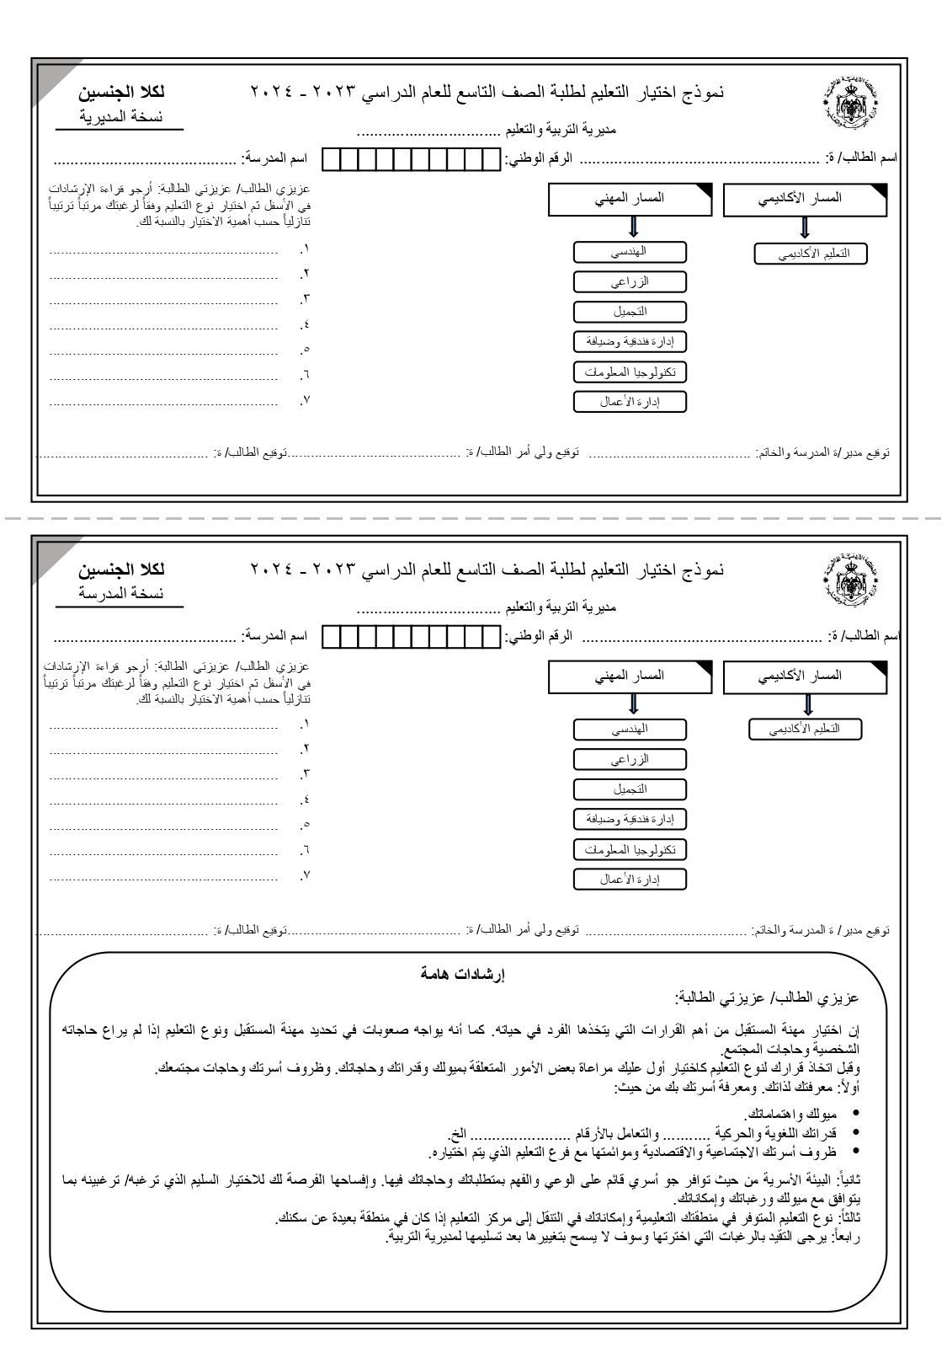

|  |  |  |  |  |  |  |  |  |  |
| --- | --- | --- | --- | --- | --- | --- | --- | --- | --- |
| **«n1»** | **«n2»** | **«n3»** | **«n4»** | **«n5»** | **«n6»** | **«n7»** | **«n8»** | **«n9»** | **«n10»** |

|  |  |  |  |  |  |  |  |  |  |
| --- | --- | --- | --- | --- | --- | --- | --- | --- | --- |
| **«n1»** | **«n2»** | **«n3»** | **«n4»** | **«n5»** | **«n6»** | **«n7»** | **«n8»** | **«n9»** | **«n10»** |

**«stname»**

**«stname»**